Application Form
Once this form is completed please return to recruitment@sarac.org.uk

Job role applied for:

Personal Details
Name:
Preferred Pronoun:
Address:

Postcode:
Landline Telephone Number:
Mobile Telephone Number:
Email Address:

Qualifications and training, where applicable
(Only enter qualifications/training relevant to this role)

Qualification/Training | School/University/Trainer | Dates (to/from)

Relevant skills, experience and abilities (refer to the JD)

Please describe your previous experiences, skills and achievements that demonstrate your appropriateness for this post, with relevance to the Job Description and Person Specification.

Employment – Please document any previous employment in this table, working backwards from your most recent/current employer.

Employer
Job Title
Salary
Responsibilities
Date from/to:

Employer
Job Title
Salary
Responsibilities
Date from/to:

Employer
Job Title
Salary
Responsibilities
Date from/to:

Employer
Job Title
Salary
Responsibilities
Date from/to:

Gaps in employment history – Please use this space to account for any gaps in your career/education history

Referees – Please supply two referees whom we can contact if you are successful in applying for this role. One must be your current/most recent employer. References checks are always carried out.

Referee 1
Name
Relationship to you
Address

Phone number
Email address

Referee 2
Name
Relationship to you
Address

Phone number
Email address

The selection process will include seeking an enhanced disclosure DBS, all expenses of which are met by sarac.

If you have previous or current, spent or unspent convictions or warnings please use the space below to give brief details:

I have no history of criminal convictions ◻

DECLARATION
I declare that, to the best of my knowledge, the information on this application form is true. I understand that if I provide false information my application will be disqualified or I could be dismissed without notice.
Signed | Date

FEEDBACK
At SARAC, we value your feedback and continuously strive to enhance our interview process and overall experience for applicants. Your input is invaluable in helping us create a more inclusive and positive environment. Please send your feedback to edi@sarac.org.uk or write your answers below.
Thank you for helping us improve!

1. Was the application form easy to navigate and complete? Yes/No
2. Did you find the information provided correct and helpful? Yes/No
3. Is there anything specific that could be improved in the recruitment process?

Please see next page for Equality and Diversity Monitoring Form

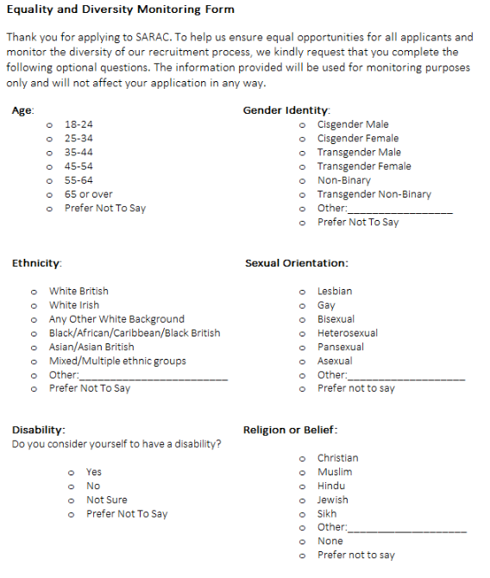

Thank you for taking the time to complete this form. Your cooperation in providing this information is greatly appreciated as we strive to promote equality and diversity within SARAC. If you have any questions or concerns regarding this form, please contact edi@sarac.org.uk.

