Application Form

Job role applied for:

Personal Details
Name:
Preferred Pronoun:
Address:

Postcode:
Landline Telephone Number:
Mobile Telephone Number:
Email Address:

Qualifications and training, where applicable
(Only enter qualifications/training relevant to this role)

Qualification/Training | School/University/Trainer | Dates (to/from)

Relevant skills, experience and abilities (refer to the JD)

Please describe your previous experiences, skills and achievements that demonstrate your appropriateness for this post, with relevance to the Job Description and Person Specification.

Employment – Please document any previous employment in this table, working backwards from your most recent/current employer.

Employer
Job Title
Salary
Responsibilities
Date from/to:

Employer
Job Title
Salary
Responsibilities
Date from/to:

Employer
Job Title
Salary
Responsibilities
Date from/to:

Employer
Job Title
Salary
Responsibilities
Date from/to:

Gaps in employment history – Please use this space to account for any gaps in your career/education history

Referees – Please supply two referees whom we can contact if you are successful in applying for this role. One must be your current/most recent employer. References checks are always carried out.

Referee 1
Name
Relationship to you
Address

Phone number
Email address

Referee 2
Name
Relationship to you
Address

Phone number
Email address

The selection process will include seeking an enhanced disclosure DBS, all expenses of which are met by sarac.

If you have previous or current, spent or unspent convictions or warnings please use the space below to give brief details:

I have no history of criminal convictions ◻

Please note: An online search of publicly available information will be undertaken for shortlisted candidates as part of the organisation’s due diligence. Candidates will have the opportunity to address any issues of concern that may arise during the search at interview.

DECLARATION
I declare that, to the best of my knowledge, the information on this application form is true. I understand that if I provide false information my application will be disqualified or I could be dismissed without notice.

Signed | Date

FEEDBACK
At SARAC, we value your feedback and continuously strive to enhance our interview process and overall experience for applicants. Your input is invaluable in helping us create a more inclusive and positive environment. Please send your feedback to edi@sarac.org.uk or write your answers below.
Thank you for helping us improve!

1. Was the application form easy to navigate and complete? Yes/No
2. Did you find the information provided correct and helpful? Yes/No
3. Is there anything specific that could be improved in the recruitment process?

Please see next page for Equality and Diversity Monitoring Form.

Please complete the Self Declaration Form.

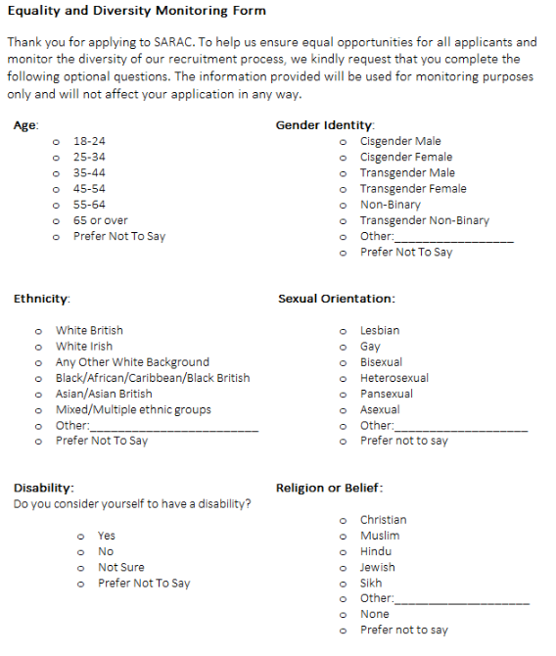

Thank you for taking the time to complete this form. Your cooperation in providing this information is greatly appreciated as we strive to promote equality and diversity within SARAC. If you have any questions or concerns regarding this form, please contact edi@sarac.org.uk.

SELF DISCLOSURE FORM

You are being asked to complete this form because the role you are applying for is covered by the Rehabilitation of Offenders Act 19784 in England, Scotland and Wales or the Rehabilitation of Offenders (Northern Ireland) Order 1978 and involves contact with children or young people.

As the role you have applied for involves contact with children, you will also be required to undergo the relevant vetting and barring checks.

All information you provide will be treated as confidential and managed in accordance with relevant data protection legislation and guidance. You have a legal right to access any information held by you.

Personal details

Name:

Previous name(s):

Address and postcode:

Telephone / mobile number:

Date of birth:

Criminal record declaration:
This role is covered by the Rehabilitation of Offenders Act 1974 in England, Scotland and Wales, or the Rehabilitation of Offenders (Northern Ireland) Order 1978. You are therefore only required to declare all unspent convictions and conditional cautions and all spent convictions and adult cautions that are not protected (i.e. eligible to be filtered).

Do you have any unspent conditional cautions or convictions in the UK or overseas? |  |  |  | YES NO
If yes, please provide further information:

Do you have any spent adult cautions (simple or conditional) or convictions in the UK or overseas that are not protected (i.e. eligible to be filtered) as defined by the Rehabilitation of Offenders Act 1974 in England, Scotland and Wales or the Rehabilitation of Offenders (Northern Ireland) Order 1978? |  |  |  | YES NO
If yes, please provide further information:

Barred list declaration

If this role has been defined as regulated activity or work it will also be subject to an enhanced with barred list check in England, Northern Ireland and Wales or checks under the Protecting Vulnerable Groups scheme in Scotland.

It is a criminal offence to apply for or accept a position working with children if you have bee barred from/listed as unsuitable to engage in regulated activity/work with children.

Are you included on the list of people bared from/listed as unsuitable to engage in regulated activity/work with children? |  |  |  | YES NO
If yes, please provide further information:

I you are not currently barred from working with children, have you been referred to the Disclosure and Barring Service (DBS) or Disclosure Scotland for consideration to be added to one of the lists? |  |  |  | YES NO
If yes, please provide further information:

Conduct declaration:

Have you ever been known to any children’s services department or police as being a risk or potential risk to children? |  |  |  | YES NO
If yes, please provide further information:

Have you ever been dismissed for misconduct from any paid or voluntary position previously held by you? |  |  |  | YES NO
If yes, please provide further information:

Have you ever been under investigation for or subject to any disciplinary sanctions in relation to your conduct at the time of your employment? |  |  |  | YES NO
If yes, please provide further information:

Have you ever been subject to any sanctions being placed on your professional registration, by a regulatory or licencing body in any country? (as applicable)  Sanctions may include: Warnings, conditions, limitations, suspensions removal or any other restrictions that may have applied to your professional registration. |  |  |  | YES NO N/A
If yes, please provide further information:

Confirmation of declaration (tick box below)

 | I agree that the information provided here may be produced in connection with recruitment purposes and I understand that an offer of employment may be withdrawn or disciplinary action may be taken if information is not disclosed by me and subsequently come to the organisation’s attention.
 | In accordance with the organisation’s procedures if required I agree to provide a valid criminal record certificate and consent to the organisation clarifying any information provided on the disclosure with the agencies providing it.
 | I agree to inform the organisation within 24 hours if I am subsequently investigated by any agency or organisation in relation to concerns about my behaviour towards children or young people.
 | I understand that the information contained on this form, the results of the criminal record check and information supplied by third parties may be supplied by the organisation to other persons or organisations in circumstances where this considered necessary to safeguard children.
By signing below, I confirm that the information I have provided on this form (or attached) is accurate. I understand that this information will not necessarily prevent me from being employed or appointed in the role above, and that I will be given an opportunity to discuss any concerns you might have before you make a final decision on my suitability for the role.

Signature of Candidate:

Print name:

Date:

